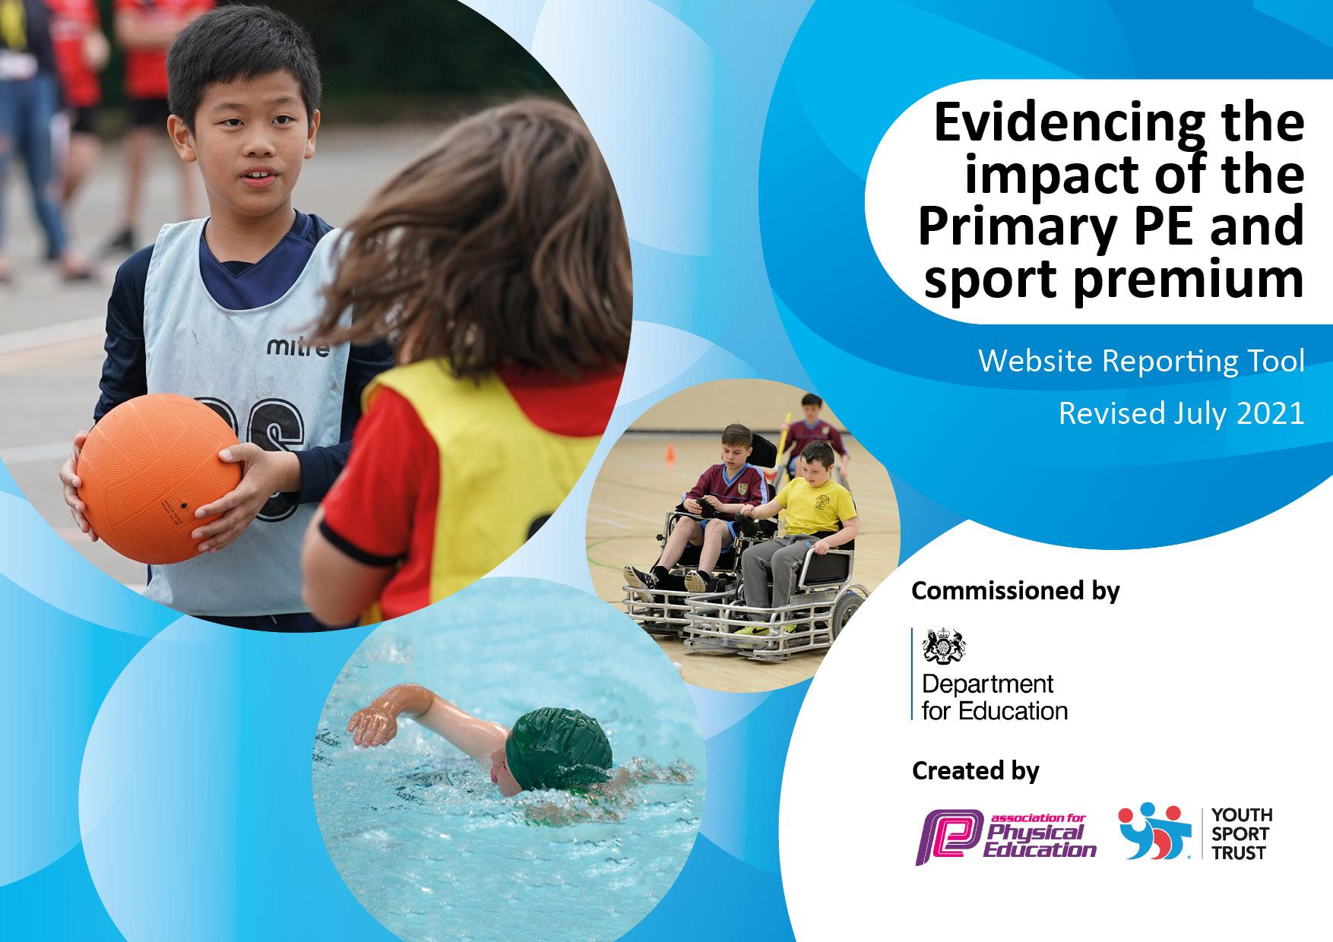

Primary PE and Sports Premium

Hasting Hill Academy Funding Details

Total amount carried over from 2019/20 | £0
Total amount allocated for 2020/21 | £17,880
How much (if any) do you intend to carry over from this total fund into 2021/22 | £0
Total amount allocated for 2021/22 | £17,630
Total amount of funding for 2021/22. To be spent and reported on by 31st July 2022. | £21,045
Total amount carried over from 2021/22 | £0
Total amount allocated for 2022/23 | £17,980
Total amount of funding for 2022/23 to be spent and reported on by 31st July 2023. | £18, 045

Meeting national curriculum requirements for swimming and water safety.  Swimming Data | 2020-2021 | 2021-2022 | 2022-2023
What percentage of your current Year 6 cohort swim competently, confidently and proficiently over a distance of at least 25 metres? | 68% | 47% | 60%
What percentage of your current Year 6 cohort use a range of strokes effectively [for example, front crawl, backstroke and breaststroke]? | 59% | 72% | 60%
What percentage of your current Year 6 cohort perform safe self-rescue in different water-based situations? | 68% | 72% | 80%
Schools can choose to use the Primary PE and sport premium to provide additional provision for swimming but this must be for activity over and above the national curriculum requirements. Have you used it in this way? | No | No | No

Action Plan and Budget Tracking

Academic Year: 2022/23 | Total fund allocated: £17,980 | Date Updated: July 2022
Key indicator 1: The engagement of all pupils in regular physical activity – Chief Medical Officers guidelines recommend that primary school pupils undertake at least 30 minutes of physical activity a day in school |  |  |  | Percentage of total allocation:
 |  |  |  | 73%
Intent | Implementation |  | Impact
School Focus | Actions | Funding | Evidence | Sustainability and next steps:
To provide quality facilities that current and future pupils will be able to use to ensure quality PE sessions  - RealPE Resources  - Active Break and Lunch activities  - Playground activities  - OPAL fully embedded. | New PE equipment to be maintained to meet approved safety standards (basketball posts, football posts, netball posts)  Improve the engagement of pupils with sport and outdoor play in both pe lessons and active break and lunchtimes - weekly timetable produced by PE Apprentice and PE lead to show plan  Behaviour and social engagement to improve through more opportunities to engage in sporting activities at break and lunch through Sports Leaders and PE Apprentice  Increase the activity levels of children in school to be in line with chief medical examiners recommendation  Use of Real PE at Home to encourage collaborative learning and physical activity outside of school hours within the home environment. | £3500  £9000  £250 | Football goals used daily twice a day during break and lunch times with both boys and girls active. 2 of the 3 pitches are used for brain breaks and 10 for 10, with caretaker ensuring safety of post connections, net fitting and pegs for stability. Basketball and netball posts used during breaks and for after school clubs.  All outdoor sporting equipment used on a daily basis with large amounts of children active during break and lunchtimes.  Small group activities led by Sports Apprentice during break and lunchtimes in preparation for sports tournaments - i.e. year 6 netball team practice twice a day practice prior to the event day.  Behaviour and activities of children has improved during break and lunchtime with very few problems or issues to deal with by staff. Play is purposeful and team skills are being developed on a daily basis. Active 10 for 10 and brain breaks are resulting in increased physical activity levels, with large scale games of football, basketball, rounders and tag being played.  RealPE at Home rollout - not implemented this year. | School caretaker to continue to maintain the safety of PE equipment available on yards and fields for sport. Football pitches to be painted on school field in autumn term to enhance the football provision and investigate possibility of painting netball and basketball lines on KS2 top yard.  Aim to provide more variety of indoor sports for children available at break and lunch times, mainly table tennis, dodgeball and archery  Change4Life support with Sports Leaders during Autumn term in order to support with Sports Leader introductions.  Investigate new ‘Bursts’ programme from Create Development and look into the possibility of purchasing to support with EY and KS1 home PE.  Ensure that new children to school are enrolled on Real PE at Home and set up with usernames and passwords.
To provide a range of after school clubs which encourage physical activity | Sports sessions will encourage weekly uptake of sports on school premises led by school staff.  New sports equipment to allow a wider range of clubs on offer for children in KS1 and KS2 |  | 17 sporting after school clubs have been offered to pupils across the 3 terms this year, with at least one physically active club taking place on 3 out of 5 weeknights per week.  Clubs have included:  football, hockey, netball, rounders, dodgeball, yoga, gymnastics, bollywood dancing, multi-skills. A total of 252 places have been occupied by HH pupils at these clubs across the year.  New sports equipment (such as dodgeball sets, netball balls and posts, hockey balls, rounders equipment, class set of footballs and goals) has allowed for clubs to run successfully and be properly resourced in terms of correct playing equipment and amount of equipment for 1:1. | Continue to maintain the level of sports clubs on offer to Hasting Hill children. Using Sports Premium, look into the possibility of using community clubs to run after school sessions.  Target to enhance the offer of sports clubs in KS1.  Offer a range of sports, making use of the equipment available at Hasting Hill.
To employ a sports apprentice to improve the sporting offer to all pupils across school. | Active playgrounds with taught sessions/competitions/tournaments during break and lunch times.  Range of After School Clubs offered across year groups  PE Apprentice to lead Sports Leaders in supporting active break and lunchtime  Gifted and Talented Programme in place.  Range of CPD opportunities to develop the subject knowledge of PE apprentice  Support in all PE lessons to ensure pupils develop their skills in a wide range of sports and make good progress within PE. |  | Some active play has occurred during break and lunchtimes. During winter term, a mini football tournament took place amongst Year 4. Preparation for competitions and events has been led by sports apprentice for the Y6 netball tournament, with training sessions taking place twice a day for the week prior to the event.  Sports Apprentice has been able to offer girls football, gymnastics, hockey, netball and dodgeball as after school clubs.  In Autumn term, sports leaders were led by sports apprentice to support with active break and lunches in both KS1 and KS2, with groups of children being active in a range of activities, skills and games.  Subject knowledge developed in RealPE through face-to-face CPD with Create Development, as well as support with lessons and assessment from PE Trust Lead. My Learning made active on Sports Apprentice Jasmine account for continual and ongoing CPD opportunities.  Sports Apprentice shadowed PE Subject Lead during autumn term to observe model lessons, gain familiarity with RealPE programme and curriculum as well as leading after-school clubs alongside MJ. | Develop the use of Y6 Sports Leaders through support from Change4Life team (book workshop for early in Autumn term)  Maintain the level of afterschool clubs offered with a target of at least 1 offer to KS1 pupils.  Make use of support from Trust PE Lead to ensure that assessment is accurate and support in making curriculum bespoke for children in school.  Continue work with SGO to match and improve on the number of competitions and events attended.  Develop more intra-school year group competitions through active break and lunchtimes - to be ran by Sports Leaders.  MJ to use ‘My Learning’ to ensure that staff are up to date with Real PE and continue their CPD journey through the Jasmine platform, as well as sharing other CPD opportunities that arise.
Key indicator 2: Increased confidence, knowledge, and skills of all staff in teaching PE and sport |  |  |  | Percentage of total allocation:
Intent | Implementation |  | Impact | 6%
School Focus | Actions | Funding | Evidence | Sustainability and next steps:
Develop teachers’ knowledge of the PE curriculum through appropriate high quality CPD | All Real PE lessons will be high quality with all staff accessing Jasmine to deliver lessons across all key stages  Subject Leader to transfer knowledge and skills to other staff as well as webinars and staff training, including sharing of the Learning Nutrition doc.  Pupils fundamental motor skills to improve through successful delivery of Real PE from teachers  Teachers and pupils will improve learning behaviours through the delivery of Real PE units and these behaviours displayed in every classroom.  Staff to use the Assessment Wheel to track and monitor pupils’ progress in PE | £695  £500 | ‘My Learning’ feature made available by subject lead and active on PE Lead and Sports Apprentice Jasmine accounts. ECTs were given access to half day CPD, run by Create Development, to deepen subject knowledge, explore curriculum and gain experience of lesson structures and Jasmine platform. Subject Lead set up staff accounts and monitored usage and log in amounts.  Through assessment wheel and end of term assessments, progress has been able to be monitored, with specific assessment support provided to Sports Apprentice and PE Lead from Trust PE Lead.  Classroom environments enriched through the visual presence of learning cogs and PE displays around school (Y6 corridor, sports halls). | MJ to use ‘My Learning’ to ensure that staff are up to date with Real PE and continue their CPD journey through the Jasmine platform, as well as sharing other CPD opportunities that arise.  Monthly ‘Did you know…?’ email about an aspect of the Real PE programme or Jasmine platform to keep staff up to date with enhancements.  Develop PE displays in both KS1 and KS2 halls. Ensure that progression posters are available and present.  Lead staff meeting on ‘Assessment Wheel’ and get termly assessments into the system.
Professional coaches to support teaching of swimming for pupils in Y6 | Improve swimming skills – increase the % of pupils able to swim at least 25m.  Improve swimming skills – increase the % of pupils able to perform safe self-rescue in different water-based situations.  Teacher subject knowledge and skills to improve through CPD from coaching in order to better support teaching of swimming  Improve confidence, develop swimming skills and teamwork. | Free provided by SHV. | Percentage of the Year 6 cohort who can swim at least 25 metres has increased from 47% in the previous academic year to 60% this year.  Safe self rescue in water has improved from 72% in 2021-2022 to 80% for the current year.  Swimming sessions have taken place on a weekly basis since November and have provided swimming for 90 pupils (84%) of key stage 2 across 3 year groups - Y4, Y5 and Y6.  Staff have observed and supported swimming sessions on a weekly basis and subject knowledge has been developed, with staff leading some groups. | Continue swimming sessions with SHV - focus being Y4 and Y5 children. Aim to secure afternoon slots, if possible.

Key indicator 3: Increased participation in competitive sport. Broader experience of a range of sports and activities offered to all pupils |  |  |  | Percentage of total allocation:
Intent | Implementation |  | Impact | 20%
School Focus | Actions | Funding | Evidence | Sustainability and next steps:
Increase schools participation in a range of sporting tournaments and events, including travel to and from fixtures/competitions.  - school sports programme competitions where appropriate.  -Evolve training/ subscription for relevant staff | Increase the number of competitive sporting events that school partake in this academic year  Develop skills and teamwork  Build on links with School Games Organiser to enter into competitive events and sporting festivals  Ensure safe travel to and from sporting venues  CPD and training for PE apprentice in using Evolve  Ensure children are kept safe throughout these sporting events | £1000  £2000  £500 | Hasting Hill has taken part in 20 sporting events, competitions or initiatives across the academic year, leading to 978 sporting opportunities in total. This is a significant increase from 21-22. These have included EFL Cup, Sportability, Tennis, WISE Girls football, as well as National School Sports Week and #LetGirlsPlay initiative.  Regular contact and communication has taken place between PE lead and SGO to enter competitions and events, with a total of 978 places taken up by pupils from all key stages of school across 20 events.  Appropriate transport has been provided to give opportunities, along with the free use of our feeder school minibus (Sandhill View) to support rising costs of transport.  Evolve support has been provided by PE Lead to ECTs in order to support offsite sporting visits and trips. | Continue links with SGO to ensure that competitions, events and festivals are attended by children from Hasting Hill Academy.  Aim to increase the number of opportunities from this year.
Key indicator 4: Broader experience of a range of sports and activities offered to all pupils |  |  |  | Percentage of total allocation:
Intent | Implementation |  | Impact | 3 %
School Focus | Actions | Funding | Evidence | Sustainability and next steps:
To increase children’s participation in a range of activities associated with the paralympics and purchase equipment to provide high quality varied PE lessons | Children will have increased knowledge of paralympic events through bespoke sessions such as wheelchair basketball, boccia.  Children will have broadened experience of playing a wider range of activities through Real PE programme  Children will have increased empathy toward and understanding of playing sports with a disability | £500 | Paralympic and disability sports are included in RealPE programme (seated volleyball) and we have sent children to sportsability and inclusive sport festivals, as well as the Sport League with North View Academy.  Through feedback and discussions with children, they now have a broader knowledge of sports, games and activities compared to previously. Children can list games as well as sports that they can play. | Aim to book specific experience sessions with disability sport groups to allow children to gain a better understanding.  Through active breaks and lunchtimes, run some Paralympic and disability sport sessions, i.e. boccia, seated volleyball  Develop Sports League idea with North View Academy - regular attendance with identified SEN/hard to reach children.
To engage children in cycling proficiency activity in the hope that this will also encourage bike riding outside of school. | Children will have increased safety skills for riding a bike on roads, tracks around the local area  Children and parents will be inspired to ride bikes in their leisure time  All children to have access to equipment to enable them to enjoy cycling in school and their leisure time  Use of Walk to School/Travel initiatives to increase the profile of cycling/scooting in order to increase physical activity levels to and from school. |  | Year 5 Bikeability took place during week beginning 31st October. Across the week, children were taught a range of activities, led by the local authority, as well as safety and bike maintenance.  Year 3 Road Safety workshops took place in October and November to support travel to and from school. | Book in bikeability session for Year 5 for 23-24 academic year.  Plan Walk to School and Travel Initiatives into the school calendar
Key indicator 5: Profile of PE and sport is raised across the school as a tool for whole school improvement |  |  |  | Percentage of total allocation:
Intent | Implementation |  | Impact | 1%
School Focus | Actions | Funding | Evidence | Sustainability and next steps:
To develop the quality of the knowledge based PE curriculum through REAL PE  To develop the quality of the skills based PE curriculum through REAL PE  To use the Real PE Learning Nutrition document to develop the ethos of learning through PE | Children to retrieve knowledge from previously taught units and link to fundamental motor skills and learning behaviours  Evidence of learning (online) to be kept in order to show progression across all year groups  Children will have progressively developed their skills from previously taught units.  Implementation of Learning Nutrition document to improve PE for all  Aim to maintain Silver and achieve the Gold award through the Great Active Sunderland School Charter.  Aim to maintain Gold and achieve Platinum award through the School Games. | £100 (nutrition workshop) | PE assessment support received from SG (Trust PE Lead) for MJ and LM to ensure that assessment is accurate and tracked across units. Evidence can be found on the drive in slides. Lesson evidence is available to see PE journey across the year.  Real PE units have been taught in order so that progression occurs from skill to skill and advances through year groups in terms of the behaviours learned.  Gold award achieved in Great Active Sunderland School Charter, improving on silver from last academic year.  Awaiting School Games Mark level. | MJ to use ‘My Learning’ to ensure that staff are up to date with Real PE and continue their CPD journey through the Jasmine platform, as well as sharing other CPD opportunities that arise.  During staff meeting of sharing assessment wheel, also share the Learnign Nutrition document and link to PE lessons. Ask all staff to display Nurtition document in classroom.  Aim to maintain Gold and achieve the higher award through the Great Active Sunderland School Charter.  Aim to maintain Gold award through the School Games Mark process..

Signed off by
Head Teacher: | Natalie Fountain
Date: | July 2022
Subject Leader: | Martin Jones
Date: | July 2022
Governor: | Jan Skelton
Date: | July 2022

Reviewed by: | Martin Jones
Date: | July 2023

