Dear children of HHA and parents and carers,
We are delighted that we have a date to welcome you all back and have been working hard behind the scenes to ensure everything is as safe as it can be for your return on the 8th of March.
We would like to take this opportunity to say how proud we are of each and every single one of you. Those of you working at home have been working hard and impressing your teachers with your home learning and we have loved seeing your pictures. Children who have been in school have also been working incredibly hard and adapted so well to changes in school. One thing is clear that the children at home and school would not have been able to do this without the support of their wonderful parents and carers. We have been overwhelmed by this support and have appreciated the positive comments regarding our home learning offer and support given by staff.
Special thanks must also go to ALL of the fantastic staff at Hasting Hill who have been working tirelessly to ensure learning is effective, things run smoothly and that we have a clean and safe school. Staff have gone above and beyond in these unprecedented times and we are so grateful for all of their efforts.
We are really looking forward to seeing you again and school will be the same as when you left before the lockdown. We have lots of safety measures in place, which are detailed below. We must remember to stay vigilant and follow the procedures to ensure everyone is as safe as can be.
Please read the information carefully so you know exactly how things will work in school when you come back.
See you soon, Miss Fountain and Mrs Robson

Children’s Bubbles
In order to enable our school to operate in as normal a way as possible, children have been organised into ‘bubbles’. These bubbles will not mix during the day and break times and lunch times will be staggered to support this. The bubbles are as follows:

Bubble | Staff
2 Year Olds | Mrs Walker and Miss Robson
Early Years | Nursery - Mrs Croft  Reception - Mrs Winder
Year 1 and 2 | Year 1 - Miss Dobbing and Miss Huggins  Year 2 - Miss Souter
Year 3 and 4 | Year 3 - Miss Nash and Mrs Scott  Year 4 - Mrs Stephenson and Miss Hanson
Year 5 and 6 | Year 5 - Mrs Jackman, Mrs Clapperton and Miss Hickson  Year 6 - Mr Jones
Staff may go between bubbles but the children from the bubbles will not mix.
Lunch times.
We will not all be in the hall eating lunches together.
Nursery will have lunch in their own building. Reception, Year 1 and 2 will use the Key Stage 1 hall in separate areas at staggered times. Year 3 and 4 will use the dinner hall and Year 5 and 6 will use the Key Stage 2 hall.
As the weather gets nicer children will be able to eat outside if they wish with pack lunches or grab bags from the kitchen.

Playtimes
You are very lucky at HHA as we have HUGE outdoor grounds so you can all play out using separate spaces. Each bubble will be allocated a play space, equipment and a time. You will not mix with any other bubble during your playtime.

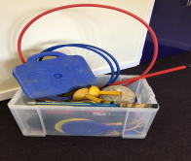
Whenever the weather permits, the field and grassed areas will be used to give you more space.
The sandpit and fixed equipment like the tyres, shelter and Trim Trail will all be closed off to minimise any potential mixing of bubbles and spread of infection.
Classrooms
Your classrooms will look like this with rows of tables:
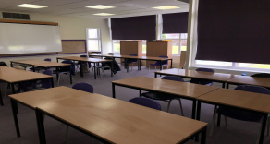
Your classroom windows will be open.
There will be lots of cleaning in your classroom throughout the day.
Your classrooms will have tissues for you to use. There is a pedal bin. You put your foot on it and open the lid and drop your tissue in. You will not need to touch the bin. The classroom bins will be emptied frequently during the day.
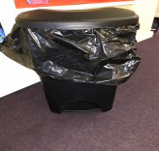
Classrooms will look a little different.
Children will NOT be expected to socially distance within their classroom, although staff will maintain a 2m distance whenever they can.
The children from year 1 upwards will sit 2 children at a table, side by side. Tables will be arranged in rows, facing the front.
Children will have their own tray with all of their books, individual pens and pencils will be provided and they will not be shared between children. We ask that children bring their own water bottle for use throughout the day. These items will only be handled by your child.
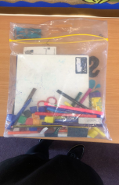
There will be things to play with in nursery and reception classrooms and these will be cleaned during the day.
Keeping everyone safe
Children will wash their hands and use hand gel lots of times during the day. REMEMBER, we sing happy birthday twice when washing hands to last for at least 20 seconds.
On entry to school, children will wash or sanitize their hands as well as before and after playing out and eating.
Parents are reminded that no child with symptoms can come into school. (Temperature above 37.8, new persistent dry cough, loss of taste and/or smell). We will send any child home who we believe is showing symptoms. They will be isolated in the medical room until they are collected and staff will be wearing full PPE for protection. We may be wrong, but we cannot be too careful. Children will be able to return to school once we have had a negative test result or after 14 days. Siblings will be sent home too and may also return after a negative test result for the person showing symptoms or 10 days. We would like parents to get a test if their child is showing symptoms so that we can act swiftly should we need to. This is for the protection of everyone and we must all play our part.
Parents are asked to remain 2m away from staff at all times. If you need to speak to a member of staff please send a message on class dojo and the member of staff will get back to you. Alternatively you can email or ring the school office.
Parents are also reminded to wear a face covering when on school site, this is paramount if we are to stop the transmission of the disease. Please follow this recommendation for the safety of everyone involved.
Children are only to bring their named water bottle [and sun cream if it is a sunny day] and coat into school. This means no bags. On PE days children can come to school wearing sports clothes. Your child’s class teacher will let you know what days your child has PE. Please ensure the clothes are appropriate and warm.
If a child is upset and unsure about coming in, please wait until all other children are in the classroom. Staff will not physically take a child, but try to persuade them with incentives.

Drop off and pick ups
In order to protect everyone, we have put the following procedures in place so that parents do not need to congregate on the yard.
2YO - Fire doors at the bottom of the bank (right hand side) next to 2YO provision Morning 2YO - 2YO door
08.45 - 11.45
Afternoon 2YO - 2YO old door
12:30 - 15:30
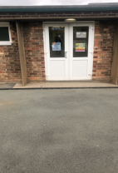

Morning Nursery - Nursery door 08.45 - 11.45
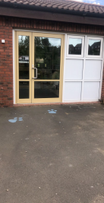
Afternoon Nursery - 2YO old door 12:30 - 15:30
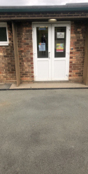

Reception - KS1 door [so not congestion on EY yard] 08:50 - 15:15

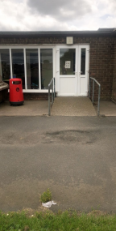

Year 1 and Year 2 - KS1 hall doors
08:40 - 15:15

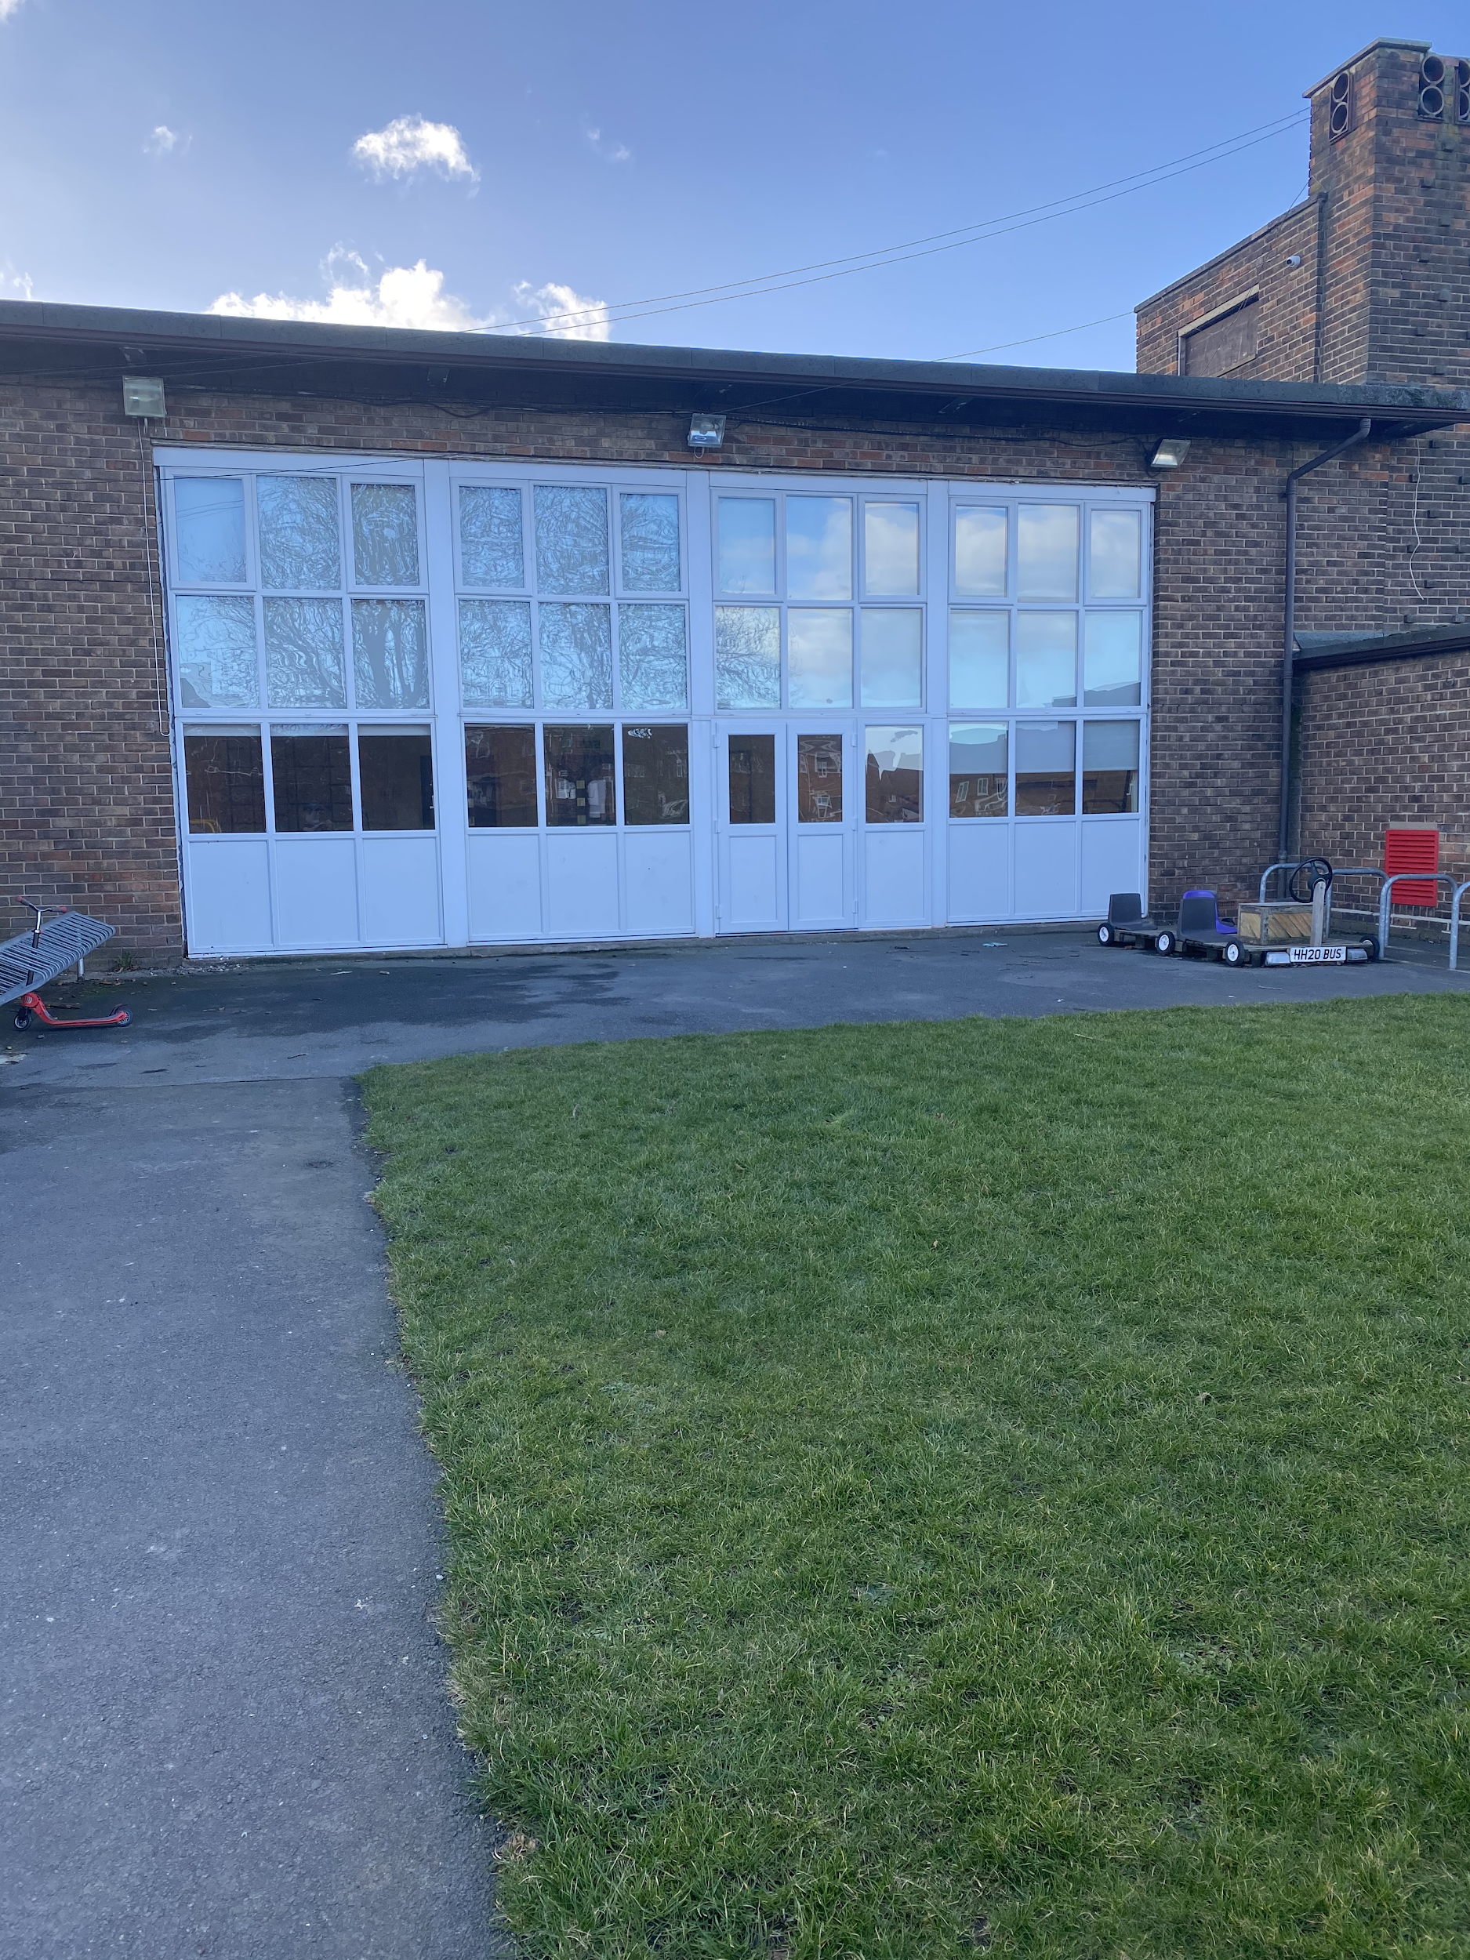

Year 3 - middle KS2 yard door
08:40 - 15:10
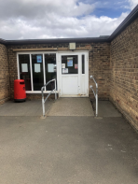
Year 4 - KS2 hall door
8:50 - 15:15
Year 5 - KS2 hall door [parents asked to leave / drop at top of bank to meet children unless other individual arrangements made]
8:40 - 15:20
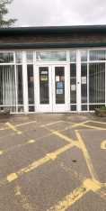
Year 6 - bottom KS2 yard door [parents asked to leave / drop at top of bank to meet children unless other individual arrangements made]
8:45 - 3:25
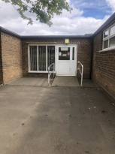
All doors will be open from 08:45 so that any child who is early for school will filter in.
One member of staff will be on the door and there will be a member of staff in each classroom.
We request that Y5 and Y6 are able to come to school unaccompanied where it is safe to do so. Please fill in the permission questionnaire using this link:
https://forms.gle/yZB6kNkBkp7bmP967
The shortcut through the school’s reception area will not be open. We are aware that this is a longer way around to access both areas of the school, however the space is very small and we do not want to put any parent at greater risk.
Breakfast Club and after school clubs
Breakfast club will continue and will be paid places only. Please book via the school office before 12.00pm on a Friday 4th for the following week. Breakfast club will run from 7.45am. Children will only be allowed to sit with children from their own bubbles and the tables will be socially distanced. The cost of breakfast club will be £2 per child, per day. You will no longer be able to drop in. We need a weekly advance notice of the day you will be attending to ensure the safety of everyone. Additional places may be available during the week but these must be pre-booked the day before. PLEASE DO NOT JUST TURN UP!
We will continue to run our FREE breakfast club but this will now be breakfast bagels in each classroom at the normal time the children come into school. The kitchen will ensure there is plenty for everyone.
After school clubs will begin after Easter and communication will be sent out before the holidays.
Assemblies and Parent Events
There will be no assemblies or whole school/parent events until further notice.
First aid
There will be a first aider attached to the bubbles. The first aider will wear PPE whilst administering first aid. New medical forms can be completed by appointment through the office. Old medical forms for inhalers can be carried over unless anything has changed.
Face coverings
If children are wearing face coverings, they will be asked to remove them when they enter school. There will be nappy sacks provided in the classroom, which they will put the mask in. This will then be disposed of in the pedal bin. If the mask is reusable, they will be given a bag and this will be taken home at the end of the day. For safety reasons staff will not be able to remove a child’s mask.
Behaviour
Any child who is not following the guidance will be reminded of the rules in place. If they continue to actively break the rules and go against the safety measures their parents will be asked to support with this. This may result in the child being sent home.
Uniform
School policy on uniform will return to normal. The guidance states there is no need to wash uniform more regularly than you normally would. Early Years children can wear jogging bottoms or leggings if this is easy for them when using the toilet.

